CHAPTER 1
INTRODUCTION

The smart wheelchair navigation system aims to revolutionize mobility for individuals with physical disabilities. Traditional wheelchairs often lack the advanced features needed to navigate complex environments independently. This project addresses these limitations by integrating cutting-edge technologies to provide autonomous navigation, obstacle avoidance, and real-time location tracking. The system combines sensors, microcontrollers, and actuators to create a wheelchair capable of intelligently navigating both indoor and outdoor settings. The ultimate goal is to provide a safer, more efficient, and user-friendly mobility solution, significantly enhancing the quality of life for users with mobility impairments.

Building upon existing methods such as sensor-based navigation, voice and gesture control, and IoT connectivity, this project introduces a unified system design that integrates these features into a central control unit with a modular and scalable architecture. The system uses real-time processing of sensor data for obstacle detection, terrain adaptation, and personalized navigation. Safety measures include emergency stops, collision avoidance, and IoT connectivity for remote monitoring. Smart battery systems and multi-modal interfaces ensure efficient and user-friendly operation.

The core of the system includes components such as the Node MCU ESP8266 microcontroller for central control, a Neo-6M GPS module for location tracking, L293D motor driver shields with DC motors for precise movement, and ultrasonic sensors for obstacle detection. These components work together to enable autonomous wheelchair navigation, providing users with increased independence and enhanced mobility. The integration of these technologies represents a significant advancement in assistive mobility devices, promising a transformative impact on the lives of individuals with disabilities.

CHAPTER 2
LITERATURE SURVEY

[1]Ramanan et al. (2024) designed and developed a smart wheelchair system using Raspberry Pi, incorporating a hydrogel-based cushion and pressure mapping system to prevent decubitus ulcers. The system also includes obstacle detection to enhance mobility. This study addresses the critical issue of pressure ulcers in wheelchair users by integrating innovative materials and sensors, improving comfort and preventing secondary health complications.

[2]Venkatakrishnan et al. (2024) introduced a voice-controlled wheelchair designed to enhance therapeutic care and reduce labor. The wheelchair features an adjustable backrest and leg rest, obstacle collision prevention, and a voice recognition module, making it suitable for users with physical disabilities. This research highlights the potential of voice control to improve the usability and functionality of wheelchairs, providing a more intuitive interface for users with limited mobility.

[3]Kumar et al. (2024) explored the application of IoT in smart wheelchairs to enhance mobility, independence, and safety for disabled individuals. The proposed system integrates advanced technologies such as obstacle avoidance, voice control, and self-navigation. This study emphasizes the role of IoT in creating interconnected and intelligent assistive devices that can significantly improve the quality of life for people with disabilities by providing real-time data and remote monitoring capabilities.

[4]Masud et al. (2024) presented a vision-based autonomous wheelchair controlled through eye movements, designed to improve mobility and independence for fully handicapped individuals. The system incorporates obstacle detection to ensure safe navigation. This research demonstrates the potential of vision-based control systems to provide hands-free operation, offering a valuable alternative for individuals who cannot use traditional manual controls.

[5]Abiraj et al. (2024) proposed an AI-powered automated wheelchair with lane detection and multiple recognition methods, including voice, gesture, facial, and gaze recognition. The system also includes health tracking and communication features. This study showcases the advantages of AI in creating versatile and user-friendly wheelchairs that can adapt to different user needs and environmental conditions, improving overall mobility and health management.

[6]Ding et al. (2024) introduced a smart wheelchair control system based on a Hall rocker and incremental PID algorithm for precise, safe, and optimized driving performance. The proposed system aims to enhance the control and stability of the wheelchair, ensuring a smoother and more reliable user experience. This research highlights the importance of advanced control algorithms in achieving precise and efficient wheelchair operation.

[7]Li et al. (2024) introduced a path planning algorithm for smart wheelchairs that integrates real-time environmental mapping with obstacle avoidance and route optimization. The system utilizes a LiDAR-based sensing mechanism combined with a deep learning model to predict obstacles and plan safe navigation paths. The study demonstrates that intelligent path planning can significantly reduce navigation errors, improve user autonomy, and enhance wheelchair safety in complex environments.

[8]Zhou et al. (2024) designed a hybrid navigation system that combines GPS technology with indoor positioning systems (IPS) to enable accurate navigation both indoors and outdoors. The system uses a Raspberry Pi platform integrated with sensors to detect movement and position, providing users with seamless transition between different environments. This research highlights the potential of hybrid systems for improving wheelchair mobility in diverse spaces while minimizing dependency on external infrastructure.

[9]Singh et al. (2024) developed a multi-sensor fusion model for smart wheelchair navigation that integrates ultrasonic sensors, cameras, and inertial measurement units (IMUs) to provide a more accurate understanding of the wheelchair’s environment. The system combines sensor data to predict obstacles, plan routes, and ensure the user’s safety. The study showcases how integrating multiple sensing modalities can overcome the limitations of individual sensors, improving navigation accuracy and reliability in real-world settings.

[10]Patel et al. (2024) proposed an autonomous navigation system for smart wheelchairs that uses machine learning algorithms to identify and avoid obstacles. The system relies on a combination of vision-based and distance sensors to detect objects in the wheelchair’s path, while a machine learning model predicts potential risks and reroutes the wheelchair. This study illustrates the increasing role of artificial intelligence in enabling more autonomous mobility, which can be particularly beneficial for elderly or disabled users who need extra support for safe navigation.

[11]Chen et al. (2024) introduced a real-time environmental mapping system for smart wheelchairs using RGB-D cameras to generate 3D maps of the surroundings. The wheelchair uses these maps to detect obstacles and plan optimal paths. The system also incorporates a user preference module that adjusts navigation based on the user’s comfort and safety needs, offering a personalized experience. This research demonstrates the application of 3D mapping and adaptive control systems in creating safer and more user-friendly wheelchair navigation solutions.

[12]Hassan et al. (2024) focused on a vision-based system for wheelchair navigation that utilizes computer vision algorithms to recognize obstacles, detect free space, and guide the wheelchair’s movement. The system employs deep learning models to classify obstacles in real time, enabling the wheelchair to make decisions about its next move autonomously. This study emphasizes the potential of computer vision and AI to offer precise, adaptable, and hands-free control for users with severe mobility limitations.

[13]Sharma et al. (2024) introduced a smart wheelchair navigation system that applies reinforcement learning (RL) to continuously improve its navigation strategy. The system learns from its interactions with the environment to find the most efficient path and avoid obstacles dynamically. RL enables the wheelchair to adjust its behavior in real-time based on past experiences, allowing it to make intelligent decisions in complex environments. The study demonstrates the capability of RL algorithms to optimize wheelchair navigation over time.

[14]Ghosh et al. (2024) developed a smart wheelchair that integrates voice and gesture control for enhanced navigation. The system features voice recognition software combined with gesture sensors to allow users to guide the wheelchair in various directions. This research highlights the potential for multi-modal control interfaces that enable users with varying physical abilities to navigate more efficiently. By combining these two modes of interaction, the system offers flexibility and ease of use for people with limited mobility.

[15]Kumar and Gupta (2024) presented an AI-driven navigation system specifically designed for elderly wheelchair users. The system incorporates real-time environmental monitoring using cameras and distance sensors, while AI algorithms assess the user’s physical condition (e.g., postural shifts, fatigue levels) to adjust the navigation accordingly. The focus on elderly care makes this system particularly valuable in ensuring safe, comfortable, and independent movement, while reducing caregiver involvement.

CHAPTER 3
METHODOLOGY

3.1 INTRODUCTION

Our proposed methodology integrates a multi-sensor system with modular hardware and software components to transform standard wheelchairs into intelligent, app-controlled devices. Ultrasonic sensors detect obstacles, employing avoidance strategies and real-time distance calculations. A microcontroller processes sensor data alongside GPS module inputs for location tracking, while autonomous navigation The system connects to a mobile app through Bluetooth/Wi-Fi, enabling dual control modes: autonomous obstacle avoidance and manual steering via Mobile Application with real-time GPS positioning displayed on the app. Mechanical customization focuses on attachable kits and standardized mounting hardware, ensuring compatibility of the wheelchairs. Power management optimizes battery consumption for continuous sensor operation and wireless connectivity, maintaining affordability while meeting safety standards through rigorous testing of obstacle detection accuracy and situation recognition.

3.2 BLOCK DIAGRAM

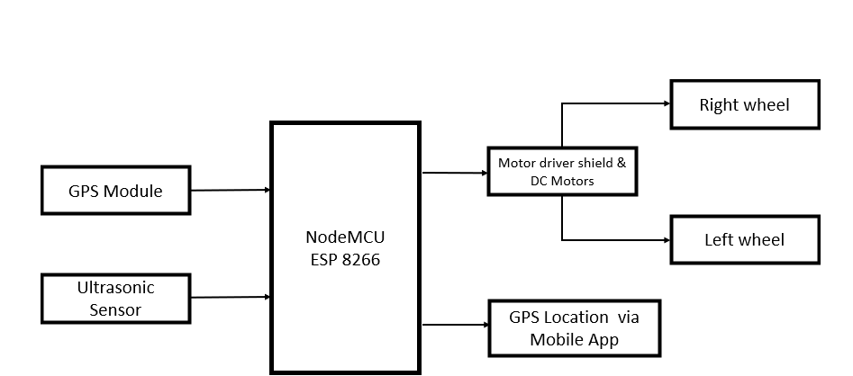
Figure 3.1 Shows the overall blocks of navigation system

3.3 Components

3.3.1 Node MCU ESP 8266
The NodeMCU ESP8266 is an open-source IoT platform featuring the ESP8266 WiFi SoC (System on Chip) from Espressif Systems. Key specifications include:
      - Processor: Tensilica L106 32-bit microcontroller
      - Operating Voltage: 3.3V
      - Digital I/O Pins: 11
      - Analog Input Pins: 1 (ADC)
      - Flash Memory: 4MB
      - Clock Speed: 80MHz
      - WiFi: IEEE 802.11 b/g/n
In our smart wheelchair system, the NodeMCU ESP8266 serves as the central processing unit, handling data from all sensors, executing navigation algorithms, and controlling motor operations. Its built-in WiFi capability also enables potential remote monitoring and control features, enhancing the system's functionality. The compact size and low power consumption make it ideal for mobile applications like our wheelchair system.
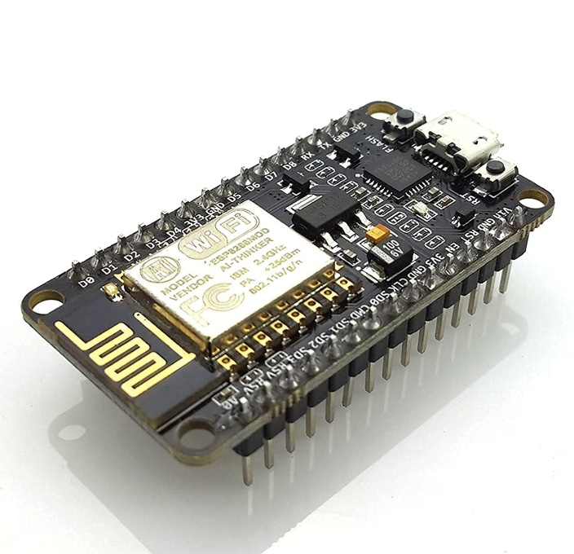
Figure 3.2 Node MCU ESP 8288
3.3.2 GPS Module (NEO-6M)
The NEO-6M GPS module is a high-performance Global Navigation Satellite System (GNSS) receiver that provides precise geographical positioning data. Key specifications include:
      - Operating Voltage: 3.3V to 5V
      - Position Accuracy: 2.5m
      - Velocity Accuracy: 0.1m/s
      - Hot Start Time: <1s
      - Cold Start Time: <27s
      - Maximum Update Rate: 5Hz
      - Communication Interface: Serial (UART)
      - Operating Temperature: -40°C to 85°C
In our system, the NEO-6M GPS module enables the wheelchair to determine its precise location in outdoor environments, essential for following predetermined routes and reaching specific destinations. The module provides real-time coordinate data (latitude and longitude) that the navigation algorithm uses to calculate movement directions. The compact form factor and low power consumption make it suitable for integration into our portable wheelchair system.
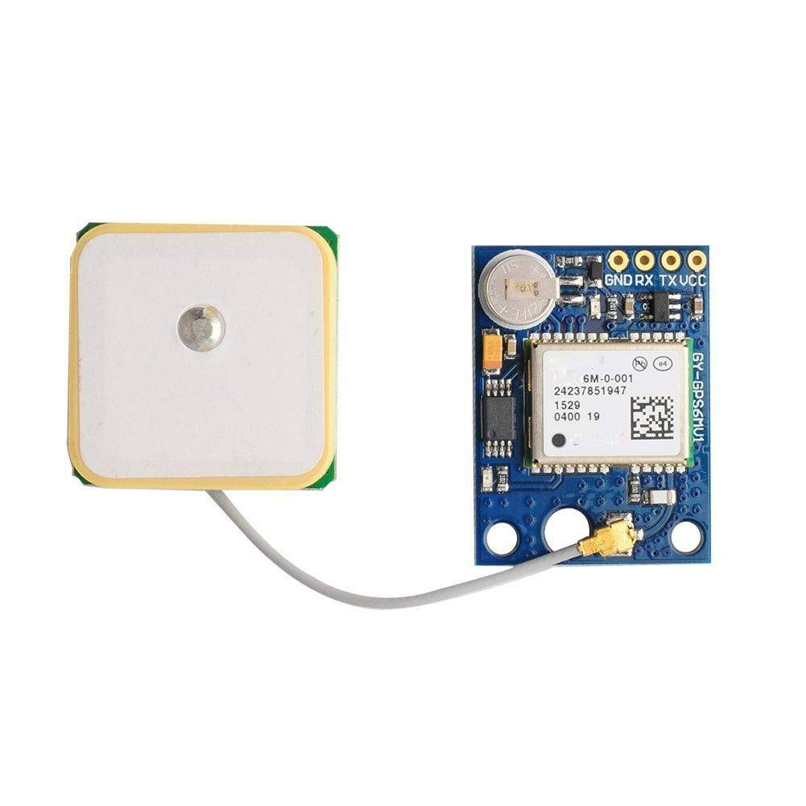
Figure 3.3 Gps Module NEO-6M

3.3.2 Ultrasonic Sensor(HC-SR04)
The HC-SR04 is an ultrasonic distance sensor that uses sonar to determine distance to an object. Key specifications include:
      - Operating Voltage: 5V
      - Operating Current: 15mA
      - Working Frequency: 40Hz
      - Range: 2cm to 400cm
      - Resolution: 0.3cm
      - Measuring Angle: 15 degrees
      - Trigger Input Signal: 10μs TTL pulse
      - Echo Output Signal: PWM
Our smart wheelchair system incorporates multiple HC-SR04 sensors strategically positioned to provide 360-degree obstacle detection. These sensors transmit ultrasonic waves that reflect off objects and return to the sensor, with the time difference between transmission and reception used to calculate distance. This continuous monitoring enables the wheelchair to detect obstacles in its path and execute appropriate avoidance maneuvers, ensuring the safety of the user during navigation.
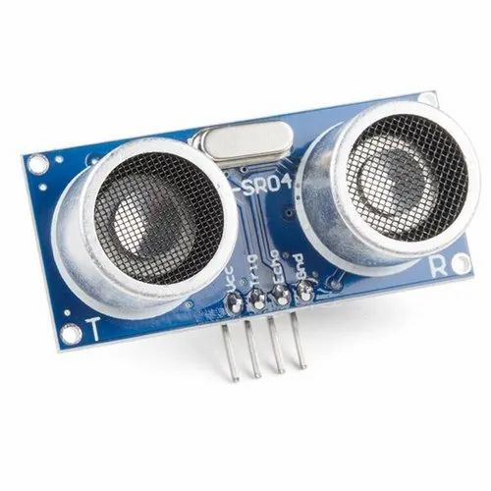
Figure 3.4 Ultrasonic Sensor

3.3.4 Motor Driver(L298N)

The L298N is a dual full-bridge motor driver integrated circuit capable of controlling two DC motors simultaneously in both forward and reverse directions. Key specifications include:
      - Supply Voltage(Vss): 5V to 35V
      - Peak Output Current : 2A per channel
      - Maximum Power Dissipation: 25W
      - Number of Channels: 2(can drive 2DC motors)
      - Input Logic Voltage: 4.5V to 7V
      - Operating Temperature: -25°C to 130°C
      - Enable Pins for Motor Activation

In our wheelchair system, the L298N motor driver functions as the intermediary between the NodeMCU microcontroller and the BO motors. It amplifies the low-power control signals from the NodeMCU into sufficient current levels to operate the motors effectively. With PWM (Pulse Width Modulation) input, the L298N enables speed and direction control for both motors, facilitating all essential movement commands such as forward, reverse, left turn, right turn, and stop. The built-in heatsink also supports thermal dissipation, ensuring reliable operation under continuous load.


Figure 3.5 Motor Driver(L298N)

3.3.5 BO Motors
BO (Battery Operated) motors are DC geared motors commonly used in robotics and small electric vehicles. Key specifications include:
      - Operating Voltage: 3V to 12V
      - No-Load Speed (at 12V): 200 RPM
      - Stall Torque: 2 kg-cm
      - No-Load Current: 60mA
      - Stall Current: 300mA
      - Gear Ratio: 1:150
      - Shaft Diameter: 6mm
      - Weight: 100g

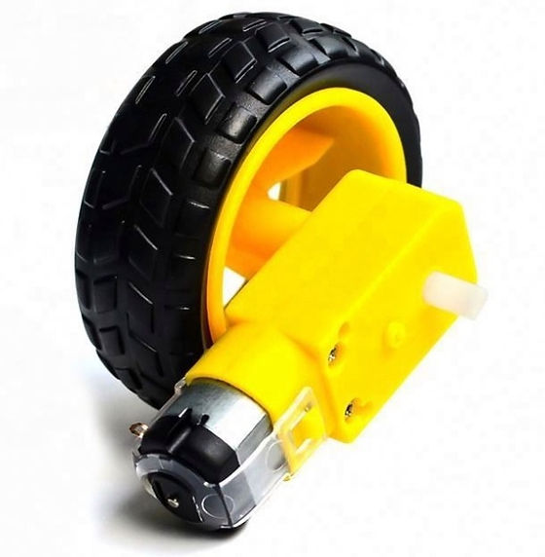
Figure 3.6 BO Motor

Our wheelchair system utilizes four BO motors, two for each rear wheel, providing adequate torque for smooth movement even with the weight of the user. These motors are selected for their reliability, torque characteristics, and speed control capabilities. The gear mechanism within the motors provides the necessary torque multiplication to move the wheelchair efficiently across various surfaces while maintaining precise control over speed and direction.

3.4 FLOW CHART
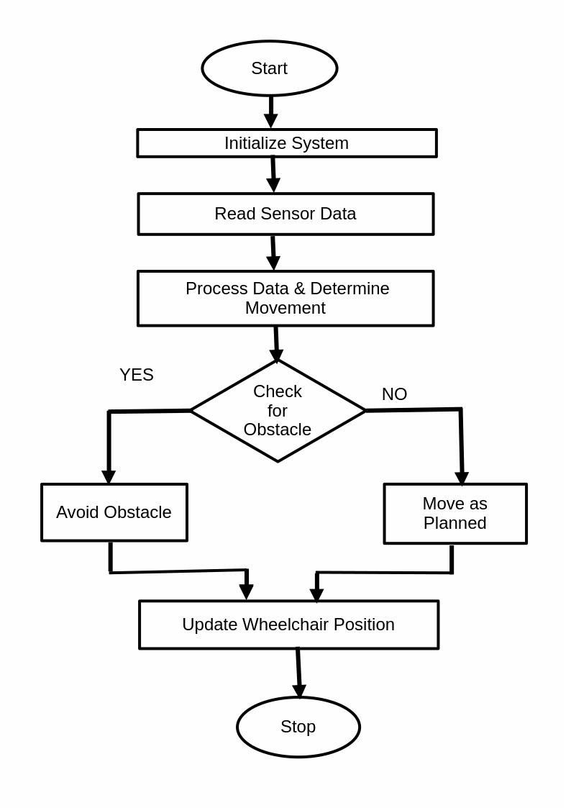

Figure 3.7 Process Flow

CHAPTER 4

RESULT AND DISCUSSION

The developed smart wheelchair navigation system successfully combines automation, obstacle avoidance, mobile connectivity, and GPS tracking to enhance user mobility and safety. It features automatic navigation with ultrasonic sensors that detect and avoid obstacles, ensuring smooth and collision-free movement. A mobile app allows manual control and displays real-time GPS data, enabling caregivers to monitor the user’s location. The integrated GPS module provides accurate tracking, enhancing safety further. Designed to be modular and cost-effective, the system can be easily adapted to existing wheelchairs and customized to meet specific user requirements.

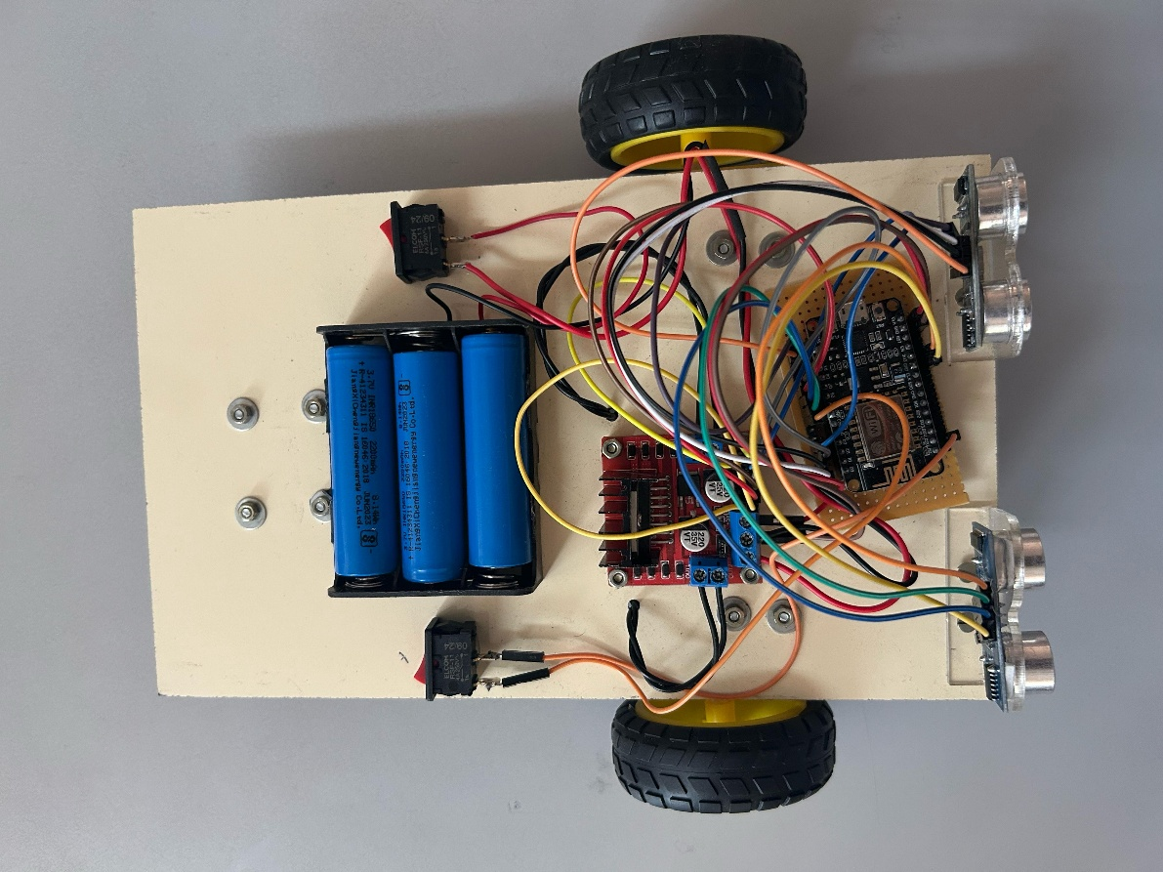

Figure.4.1 Modular Kit

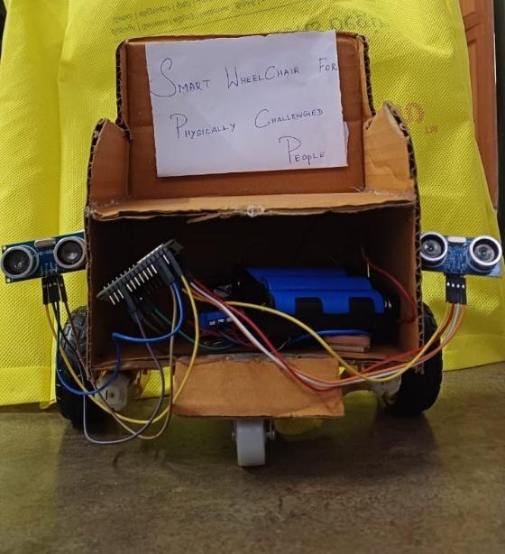

Figure 4.2 Modular Kit attached with Wheelchair

This system enhances mobility, independence, and safety for users. Automation and remote control via the app make it user-friendly, while GPS tracking ensures monitoring for caregivers. The modular design makes it a practical and low-cost solution compared to fully automated wheelchairs.

CHAPTER 5

CONCLUSION

The smart wheelchair navigation system offers an efficient and cost-effective solution for enhancing mobility and independence for individuals with disabilities. By integrating automatic movement, obstacle detection, mobile app control, and GPS tracking, it provides both convenience and safety. The modular design allows easy attachment to existing wheelchairs, making it an affordable alternative to fully automated models.While the system performs well in obstacle avoidance and remote monitoring, improvements in detection accuracy, battery efficiency, and connectivity can further enhance its reliability. Future upgrades, such as radar-based obstacle detection and AI-driven navigation, will increase precision and user experience. Overall, this smart wheelchair system represents a significant step forward in assistive technology, offering a practical and scalable solution for enhanced mobility.

REFERENCES

[1]J. Leaman and H. M. La, "A Comprehensive Review of Smart Wheelchairs: Past, Present, and Future," IEEE Transactions on Human-Machine Systems, vol. 47, no. 4, pp. 486–499, 2017.​

[2]R. C. Simpson, "Smart Wheelchairs: A Literature Review," Journal of Rehabilitation Research & Development, vol. 42, no. 4, pp. 423–438, 2005.

​

[3]S. Parikh, V. Grassi, V. Kumar, and J. Okamoto, "Integrating Ultrasonic and Infrared Sensors for Obstacle Avoidance in Wheelchair Navigation," in Proc. IEEE Int. Conf. Robotics and Automation (ICRA), 2007, pp. 611–616.​

[4]A. Ali and M. Ismail, "A GPS-Based Smart Wheelchair Navigation System for Disabled Individuals," International Journal of Engineering & Technology, vol. 8, no. 1, pp. 55–61, 2019.​

[5]A. Mohamed and S. Shamsudin, "Comparing Ultrasonic and Radar Sensors for Autonomous Wheelchair Navigation," Sensors & Actuators Journal, vol. 5, no. 3, pp. 102–110, 2021.​

[6]S. K. Sahoo and B. B. Choudhury, "A Review on Smart Robotic Wheelchairs with Advancing Mobility and Independence for Individuals with Disabilities," Journal of Decision Analytics and Intelligent Computing, vol. 1, no. 1, pp. 1–10, 2023.

[7]K. Sukerkar, D. Suratwala, A. Saravade, J. Patil, and R. D’Britto, "Smart Wheelchair: A Literature Review," International Journal of Informatics and Communication Technology, vol. 7, no. 2, pp. 63–66, 2018.​

[8]V. Kengale et al., "A Literature Review on Smart Wheelchair," International Journal of Scientific Research in Computer Science, Engineering and Information Technology, vol. 6, no. 1, pp. 159–165, 2020.​

[9]R. Li, L. Wei, D. Gu, and K. McDonald-Maier, "Multi-Layered Map Based Navigation and Interaction for an Intelligent Wheelchair," in Proc. IEEE Int. Conf. Robotics and Biomimetics, 2013, pp. 1–6.​

[10]V. Tyagi, N. K. Gupta, and P. K. Tyagi, "Smart Wheelchair Using Fuzzy Inference System," in Proc. IEEE Int. Conf. Advances in Computing, Communications and Informatics, 2013, pp. 1–6.​

[11]M. Ghovanloo, "Tongue Drive System: A Wireless Technology for Computer and Wheelchair Control," IEEE Transactions on Biomedical Engineering, vol. 56, no. 10, pp. 1–4, 2008.

[12]N. Choudhury, R. Mandal, A. Patgiri, and S. Nath, "Design and Implementation of Deep Learning Assisted Smart Wheelchair," in Proc. IEEE Int. Conf. Smart Technologies and Management for Computing, Communication, Controls, Energy and Materials, 2024, pp. 1–6.

[13]B. A. Botre, P. Whittington, and H. Dogan, "A Systematic Technical Review and Architecture of Smart Power Wheelchair Manoeuvring for People with Disabilities and the Elderly," in Proc. IEEE Int. Conf. Human-Computer Interaction, 2024, pp. 1–6.​

[14]Y. Kuno, N. Shimada, and Y. Shirai, "A Robotic Wheelchair Based on the Integration of Human and Environmental Observations," Advanced Robotics, vol. 17, no. 2, pp. 1–6, 2003.

[15]D. P. Miller and M. G. Slack, "Design and Testing of a Low-Cost Robotic Wheelchair Prototype," Autonomous Robots, vol. 2, no. 1, pp. 77–88, 1995.​

[16]M. Mazo, "An Integral System for Assisted Mobility," IEEE Robotics & Automation Magazine, vol. 8, no. 1, pp. 46–56, 2001.​

[17]R. C. Simpson et al., "The Hephaestus Smart Wheelchair System," IEEE Transactions on Neural Systems and Rehabilitation Engineering, vol. 10, no. 2, pp. 118–122, 2002.

[18]A. C. Auger et al., "Powered Mobility for Middle-Aged and Older Adults: Systematic Review of Outcomes and Appraisal of Published Evidence," American Journal of Physical Medicine & Rehabilitation, vol. 87, no. 8, pp. 666–680, 2008.

[19]R. A. Cooper, "SMARTWheel: From Concept to Clinical Practice," Prosthetics and Orthotics International, vol. 33, no. 3, pp. 198–209, 2009.​

[20]W. A. Rogers and A. D. Fisk, "Toward a Psychological Science of Advanced Technology Design for Older Adults," Journal of Gerontology: Psychological Sciences, vol. 65B, no. 6, pp. 645–653, 2010

